People’s Democratic Republic of Algeria

Ministry of Higher Education and Scientific Research

University May 8th – Guelma –

Faculty of Mathematics, Computer Science and sciences of matter

Department of Computer Science

tutoring Platform for Student Guidance and Monitoring

|  |  |  |
| --- | --- | --- |
|  |  |  |

Academic Year : 2024/2025

Acknowledgements

We extend our sincere thanks to our supervisor (LAFIFI Yacine) for their support and valuable guidance throughout the implementation of this project.

We also thank all members of the institution for their collaboration, and our fellow classmates for their teamwork and encouragement.

Finally, we are grateful to our families for their continued moral support.

Table of Contents

I General Introduction 4

I.1 Problem Statement 5

I.2 Objectives 5

**II****Analysis of the Existing System** 6

II.1 Host Institution Overview 6

Ⅰ.2 Simplified Organization Chart : 7

I.3 Existing Hardware and Software 8

I.4 Limitations of the Traditional System 8

**III****Proposed System Modeling** 9

Ⅲ.1 Business Rules 9

Ⅲ.2 Data Description (MCD / MLD) 9

Ⅲ.3 Processing Description (MCT) 13

Ⅲ. 3.1 Student Interface: 14

Ⅲ. 3.2 Tutor Interface: 14

Ⅲ. 3.3 Administrator Interface: 15

IV **System Development** 16

Ⅰ.V.1 General Architecture of system 16

Ⅰ.V.2 Description of Key Features by Role 17

Ⅰ.V.2.1 Student : 17

Ⅰ.V.2.2 Tutor : 20

Ⅰ.V.2.3 Administrator : 21

Ⅰ.V.2.4 Technologies and Tools Used: 22

V **General Conclusion** 22

V. 1. Conclusion: 22

V. 2. Difficulties Encountered 23

V. 3 Limitations and Anomalies in the system 24

V.3.1 Limitations: 24

V.3.2 Anomalies: 24

V. 4 Futur Perspectives 24

List of Figures and Tables

**Figures**

Figure 1 MCD of the system 9

Figure 2. the MCD of the system 16

Figure 3. general architecture of the system 17

**Tables**

Table 1 Use case Diagram 6

Table 2. Technologies and Tools Used 15

# General Introduction

At the beginning of each academic year, the Ministry in charge of higher education takes a set of measures to ensure a successful university start. This is due to the change in the learning environment for new baccalaureate holders who encounter at university a teaching system that is completely different from the one they experienced in high school. Indeed, new baccalaureate holders are not required to attend most lectures, there is no control over their behavior with other students of the same age, etc. Furthermore, these students must follow a new teaching system based on teaching units, credits, tutorials, and more.

Among the measures taken at the beginning of each academic year is the support of new baccalaureate holders during their first years of study. This support is assigned to teachers or senior students. This is the task of tutoring. In fact, this task was introduced in Algerian universities in January 2009 and concerns all first-year university students. It is in this context that this project is framed, aiming to implement a tutoring system within the Computer Science Department of the University of Guelma.

## Problem Statement

Despite the introduction of tutoring programs in Algerian universities since 2009, many first-year students continue to face academic, social, and administrative difficulties due to the absence of a structured, interactive, and accessible support system. The current tutoring approach lacks digital tools for effective management and communication. Therefore, how can we design and implement a digital tutoring system that facilitates efficient support, improves student adaptation, and enables tutors and administrators to follow up and respond to students’ needs more effectively?

## Objectives

Through this system, called "Lead My Way", each new baccalaureate holder can request help and support from their tutor. This assistance can be provided in-person or remotely. Moreover, it addresses all the students’ concerns, whether educational, social, or administrative. Additionally, the system can offer a frequently asked questions section addressing the most common concerns raised by students.

The objectives of the system can be summarized as follows:

1. To provide a user-friendly interface for each human actor in the system (administrator, tutor, and student).

2. To provide tutors with an interface that allows them to view and respond to learners’ assistance requests, schedule meetings with them, etc.

3. To provide students with a set of tools that enable them to submit assistance requests to tutors, request appointments with their tutors, etc.

4. To offer students a dashboard to track their tutoring activities.

5. To offer the administrator an interface that facilitates their tasks, such as validating the accounts of other human actors, assigning learners to tutors, and monitoring their activities.

**Finally**, we must specify that this project is carried out within the Computer Science Department of the University of Guelma. This department has a very large number of first-year students enrolled in one of the three offered programs: an academic bachelor's degree, an engineering degree, and a professional bachelor's degree.

This report is organized as follows. In the next section, we provide an overview of the Computer Science Department as well as the programs offered to students involved in the tutoring. Then, we present the system design, including the conceptual data model and the structure of the database used. Next, we introduce the system's functionalities along with some interfaces of the "Lead My Way" system. Finally, we provide a general conclusion along with an outline of some system limitations and encountered challenges.

# Analysis of the Existing System

## Host Institution Overview

The Faculty of Mathematics, Computer Science, and Material Sciences (MISM) is one of the seven faculties of the University of May 8, 1945, Guelma. It was established in 2010 following the division of the Faculty of Science and Engineering into three separate faculties. It is structured as follows:

* A Faculty Administration comprising two Vice-Dean offices and a General Secretariat.
* Three (03) departments: Material Sciences, Mathematics, and Computer Science

- ‘Lead My Way’ targets first year universirty students who aims at finding a tutor to guide them start their academic journey.

## Ⅰ.2 Simplified Organization Chart :

**Vice Dean : in charge of studies and student-related affairs and post-graduation, scientific research, and external relations**

**General Secretariat : Personnel Service : Teaching Staff Section ’Administrative Staff Section**

**Budget and Accounting Service : Budget Section , Accounting Section**

**Scientific, Cultural, and Sports Activities Service**

**Logistics and Maintenance Service : Logistics Section ,Maintenance Section**

**Head of Department : Deputy Head of Department for Undergraduate Teaching and Evaluation : Schooling Service ’ Teaching and Evaluation Monitoring Service   
Deputy Head of Department for Post-Graduation and Scientific Research : Graduate and Postgraduate Training Service , Research Activities Monitoring Service**

**and we focued on:**

* Administration
* Academic Affairs
* Orientation Services
* Teaching Staff (Tutors)
* Students

## Existing Hardware and Software

**Hardware:**

**Paper Materials:** The university continues to utilize paper-based materials for a range of administrative and academic functions. This includes student admission files, fee receipts, enrollment forms, academic transcripts, and communication documents for students and parents.

**Computers:** The university maintains a limited number of desktop computers, primarily allocated to administrative offices. These machines are installed with Microsoft Office Suite to support day-to-day operations including documentation, data processing, and internal communications.

**Internet Connection:** The campus is equipped with an internet connection that supports academic research, faculty and administrative email communications, student portal access, and the retrieval of online academic and institutional resources.

**Printers and Scanners:** These are available across administrative departments and faculty offices for generating official documents, reproducing course materials, and scanning academic records or administrative paperwork.

**Software:** Office tools, Learning Management System (LMS) which is not designed for tutoring management

## Limitations of the Traditional System

* Required physical presence
* Unpredictable tutor availability
* Scattered communication across actors
* No centralized record of interactions
* Students must go to campus and wait for the tutor to arrive, then ask the admin whether the time is suitable. This often results in unnecessary trips and wasted time.

# Proposed System Modeling

## Ⅲ.1 Business Rules

**The Different management rules derived :**

* Only first year students can create new accounts
* Students and tutors’ accounts must be validated by the administrator before access.
* Tutors have to be either master degree students or university teachers.
* Each tutor can have more than one student. But, students can only have one specific tutor.
* Tutors can only access to data of students assigned to them.
* Each student has access only to their personal data and the information of their assigned tutors.
* Appointments and questions are private between the student and his tutor.
* Administrators have global access to oversee and manage all users and interactions.

## Ⅲ.2 Data Description (MCD / MLD)

The database is designed to ensure a secure and structured flow of information between students, tutors, and administrators.To design the database, we used the Merise method which includes two main models: the conceptual data model “MCD” and the logical data model “MLD”

## 

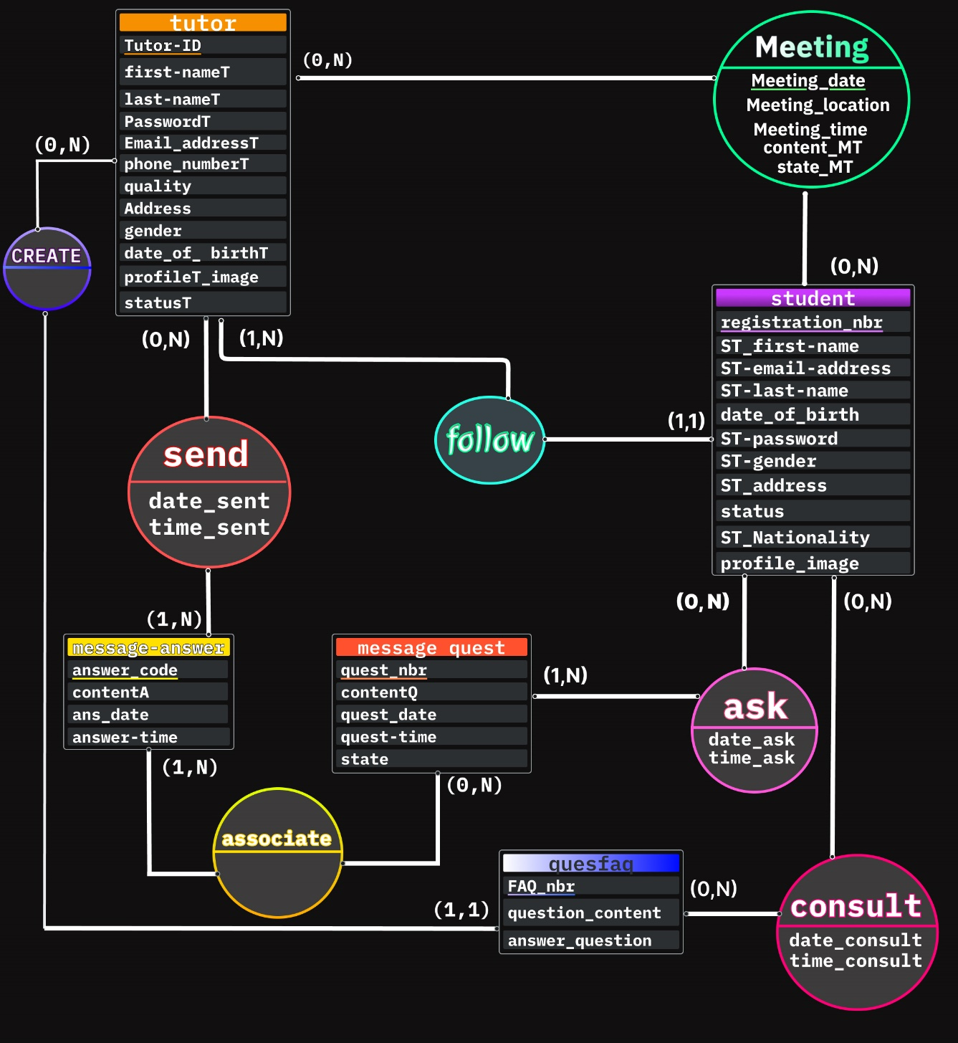

Figure 1. the MCD of the system

Ths is a detailed description of the entities and associations present in the model Data Conceptual (MCD) proposed for the tutoring system

**Entities:** in our MCD, we can see the following entities:

* Student: contains the information necessary for the registration of the student on the site.
  + - **Attributes:**
  + registration_nbr: “Registration number” is a unique identifier of the student “primary key”.
  + ST-email-address: E-mail address of the student.
  + date_of_birth: The student’s date of birth.
  + ST_first-name: Student’s first name.
  + ST-last-name: Student’s surname.
  + ST-password: Student’s password (It must be composed of 8 characters or more).
  + ST-gender:Gender of the student.
  + ST_address: Student’s address.
  + ST_Nationality:Nationality of student.
  + Profile_image
  + status: Student status ('pending', 'approved', 'rejected').
* tutor: contains the information required for the tutor to register on the site.
  + **Attributes:**

Tutor-ID: is a unique identifier of the tutor “primary key” .

First-nameT: Name of the tutor.

Last-nameT: Surname of the tutor.

Password: Tutor’s password (Must be 8 or more characters).

Email_addressT: Email address of the tutor.

phone_numberT: Phone number.

Address: Tutor’s address.

* + gender: Gender of tutrur.
  + date_of_birthT: Date of birth of tutor.
  + Profile_image .
  + quality: Quality/Specialization (teacher, Sudent Master).
  + statusT: Tutor status ('pending', 'approved', 'rejected').
* message_quest: Represents the questions that students ask their tutors
  + - **Attributes:**
  + quest_nbr : Question number “primary key”
  + contentQ: Content of question .
  + quest_date: The date or question was asked.
  + quest-time: The time at which the question was asked.
  + state : Question status ('pending', 'answered').
* message_answer: Stores tutor’s responses to student questions.
  + - **Attributes:**
  + answer_code : “primary key” .
  + contentA: Content of the response.
  + ans_date: Date of response.
  + Answer-time: Time of the response.
* quesfaq: Contains the most frequently asked questions (FAQ) and their corresponding answers.
  + - **Attributes:**
  + FAQ_nbr: FAQ number “primary key” .
  + question_content: Contents of the FAQ question.
  + answer_question: Answer to the FAQ question.

**N-N associations become tables:**

* Meeting: Manages the details of meetings between students and their tutors
* Send: A tutor will respond to students’ questions.
* Asq: A student may ask zero or more questions
* Associate: Allows you to link an answer to one or more questions, or vice versa, a question to zero or multiple answers.
* Consult: A student can consult zero or more FAQs.

**Data logic model (MLD):**

The MLD is a technical representation of the database schema, transforming the MCD in tables, columns and keys, intended to be implemented in a management system database (DBMS) to optimize the storage, access and handling of data. The proposed MLD is:

tutor ( Tutor_ID , first_nameT , last_nameT , date_of_birthT , PasswordT, Email_addressT , phone_numberT , quality,gender, Address , profileT_image , status ).

Student ( registration_nbr, first_nameST , ST_email_address , ST_last_name , date_of_birth , ST_password , ST_gender,ST_Nationality , ST_address , status , profile_image , #Tutor_ID ).

Message_quest ( quest_nbr , contentQ , quest_date , quest_time , state ).

Message_answer( answer_code, contentA , ans_date , answer_time).

quesfaq( FAQ_nbr , question_content , answer_question , #Tutor_ID ).

Meeting (#Tutor_ID , #registration_nbr , Meeting_date ,Meeting_time , meeting_location , content_MT , state_MT ) .

send(#Tutor_ID , #answer_code , date_sent , time_sent ).

ask ( #quest_nbr , #registration_nbr , date_ask , time_ask ).

associate(#answer_code , #quest_nbr ).

Consult(#FAQ_nbr , #registration_nbr , date_consult , time_consult ).

## Ⅲ.3 Processing Description (MCT)

The Conceptual Processing Model (MCT) describes the core logic and information flows for each actor in the application web.

### Ⅲ. 3.1 Student Interface:

1. Register/Login:

* Inputs: personal informations,email, password,registration number.
* Process: account creation and waiting for admin validation.
* Output: account status and access to dashboard.

1. Access the Profile:

* Inputs: photo, personal informations,email, password,registration number.
* Process: update the user’s profile photo
* Output: new profile display

1. Submit a Question:

* Inputs: question content
* Process: save in DB,
* Output: apear to assigned tutor, status = 'unanswered'

1. Request Appointment

* Inputs: date, time,Place .topic.
* Process: create meeting entry with status 'pending'
* Output: listed in both student and tutor interface.

### Ⅲ. 3.2 Tutor Interface:

1. View Assigned Students

* Inputs: tutor ID
* Process: retrieve associated students
* Output: display student list

1. Respond to Questions

* Inputs: question ID, response text
* Process: update question with answer
* Output: apear to student, mark question as answered

1. Manage Appointments

* Inputs: meeting ID, new status.
* Process: update meeting status (accept/reject/reschedule)
* Output: notify student.

1. FAQ Management

* Inputs: new FAQ entries
* Process: create/reset FAQ
* Output: updated content accessible to students

### Ⅲ. 3.3 Administrator Interface:

1. Validate Accounts

* Inputs: student and tutor registration details
* Process: approve or rejects students and tutors ,select a tutor for each student
* Output: status update

1. Send Notifications

* Inputs: target group, message content
* Process: insert into Notifications table
* Output: appears in user dashboard

1. System Supervision

* Inputs: queries, reports, statistics
* Process: analyze data, generate logs
* Output: administrative overview dashboard

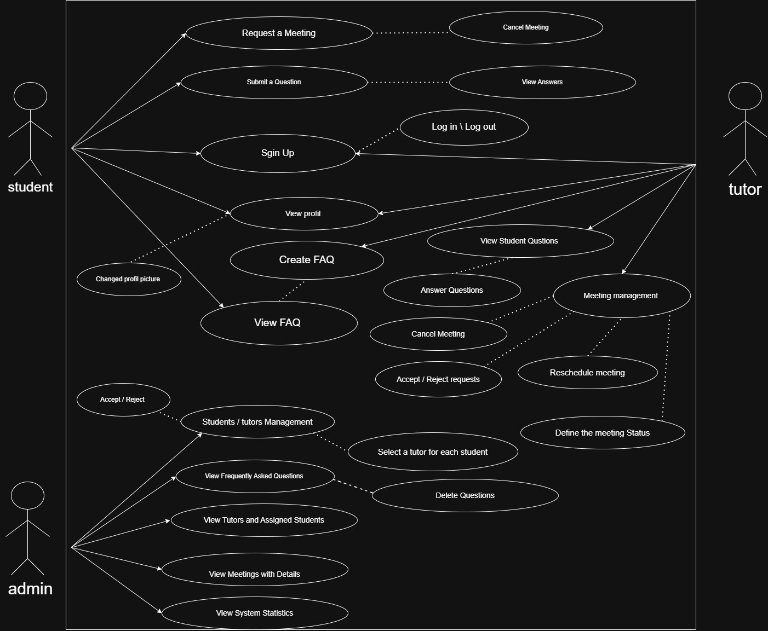

Figure 2 : use case diagram

# **System Development**



## Ⅰ.V.1 General Architecture of system

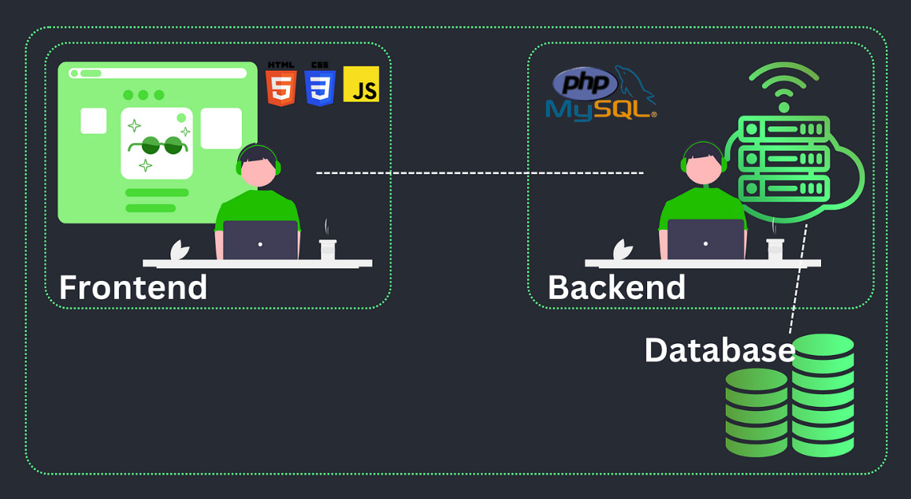

Figure 3. general architechture of the system

The proposed architecture of the information management system for the Lead My Way website consists of three front-end and back-end interfaces. The front-end includes three interfaces: one for students, one for tutors, and one for administrators, it developed using HTML, CSS, and JavaScript. It ensures an intuitive user experience for all roles. and can be accessed via a web browser. HTTP requests generated by student/tutor/admin interactions are processed by an Apache server in the back-end, where PHP executes the necessary business logic and interacts with a MySQL database. HTML responses are then sent to the front-end for display to users. MySQL stores and manages all important informations, such as tutors, students, appointments, and questions

## Ⅰ.V.2 **Description of Key Features by Role**

### Ⅰ.V.2.1 Student :

* Secure Login System: Includes a "Remember Me" functionality.
* Profile Management: Edit profile photo.
* The "Home" Interface :serves as the student’s control panel, displaying a summary of their recent activity within the platform,it includes the following elements:Answered Questions ,Appointments, Answered Questions,Last Asked Question, Upcoming Appointment with date, time, and place .
* The "FAQ" Interface : To help students quickly find answers to common questions without needing to contact a tutor or admin, it contains : Clickable questions that expand to show answers, A search bar for filtering questions.
* The "Question" Interface : allow students to ask questions and track their responses.

Figure 4. Student’ s Home interface

* The "**Meeting" Interface** : allows students to manage their appointments with the assigned tutor.
* The "My Tutor" Interface: display the student’s assigned tutor information

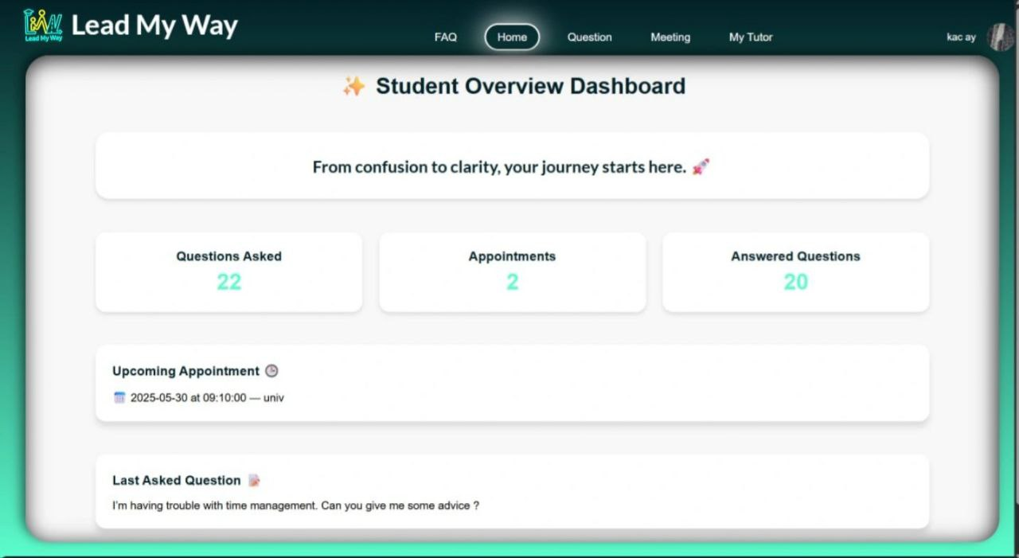

Appointment Request Workflow :

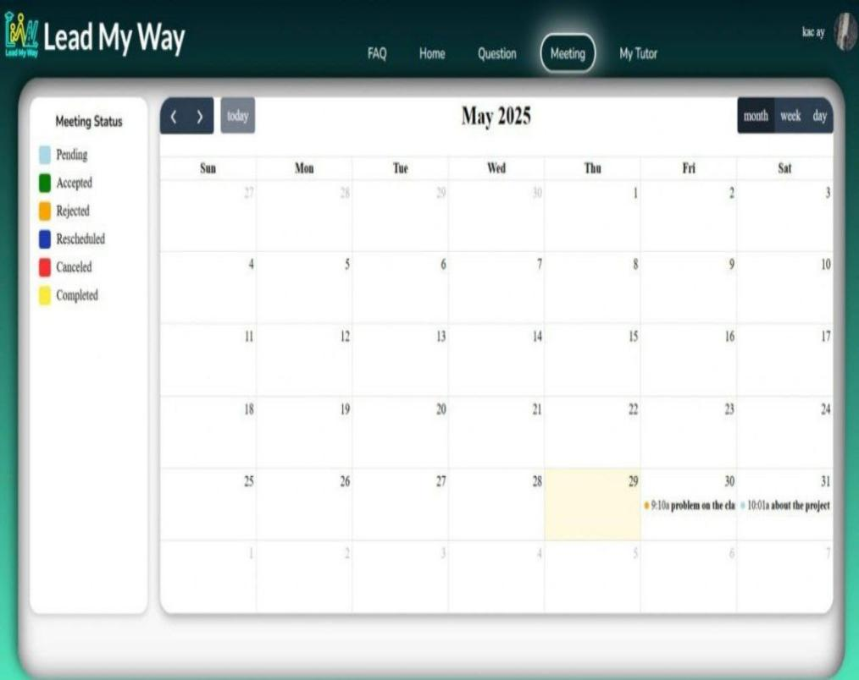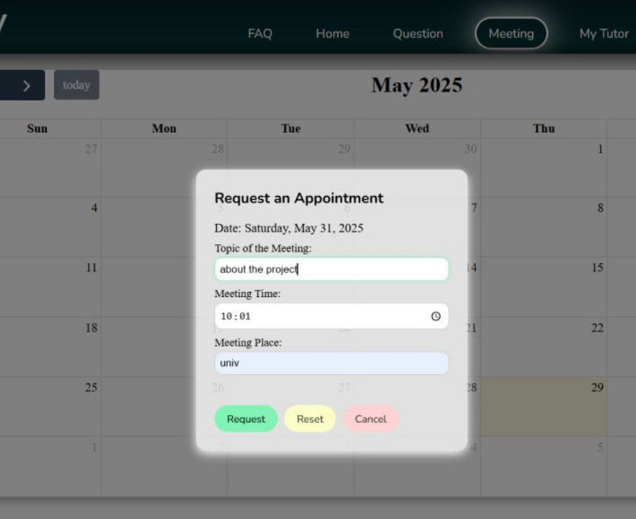 the platform enables students to request academic appointments by selecting a date, time, and providing a short message describing the purpose. Once submitted, the request is stored in the system and marked as “pending”. Tutors have access to these requests and can either approve the suggested time or propose a new one. The student is notified of the tutor’s response and can view the final appointment

details directly from the interface.

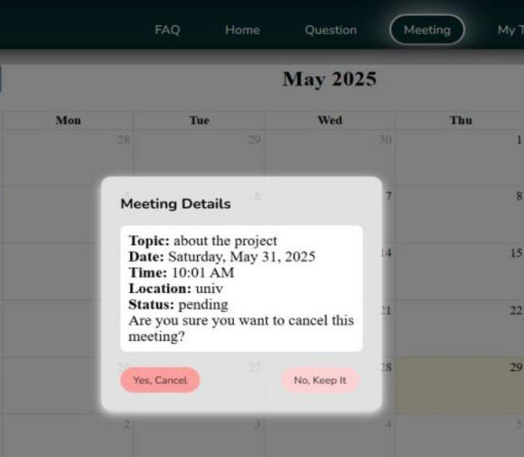

Figure 5.Student’s Meeting interfaces

### Ⅰ.V.2.2 Tutor :

This section of the system provides a set of interfaces specifically designed for teachers to facilitate their work and enable them to manage their relationships with students through:

* The "My Students" interface: Teachers can only view the data of students they personally supervise. They are not permitted to access the data of any student outside their supervision.
* The "My Profile" interface**:** Allows teachers to access their personal information, such as their first and last name, phone number, email and address, with the ability to edit their profile picture when needed.
* The "Meeting" interface**:** Displays all meetings proposed by students to the teacher. Teachers can edit meeting details, such as date, location, and status, using the "Edit" button, and can delete meetings if necessary. Meeting statuses include: Pending, Accepted, Declined, Rescheduled, Completed, Missed, and Canceled..
* The "Questions" interface**:** Teachers can respond to students' questions.
* The " FAQ " interface **:** contains a list of the most frequently asked questions by students and allows teachers to add new questions and their answers, which contributes to enriching the content and saving time for both students and teachers.

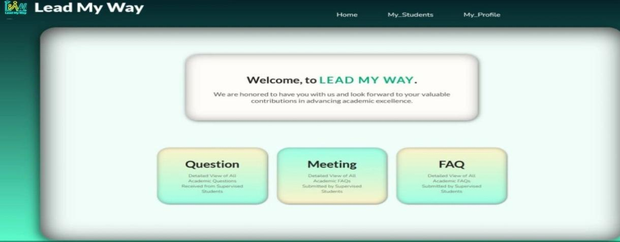

Figure 6. Tutor’s Home interface

### Ⅰ.V.2.3 Administrator :

* Account Validation: Approve or reject student accounts based on registration data and select tutor for each student.
* System Monitoring: View all users, their activity,Questions ,Frequently asked questions and platform statistics.
* Broadcast Notifications: Send general or targeted messages to users.

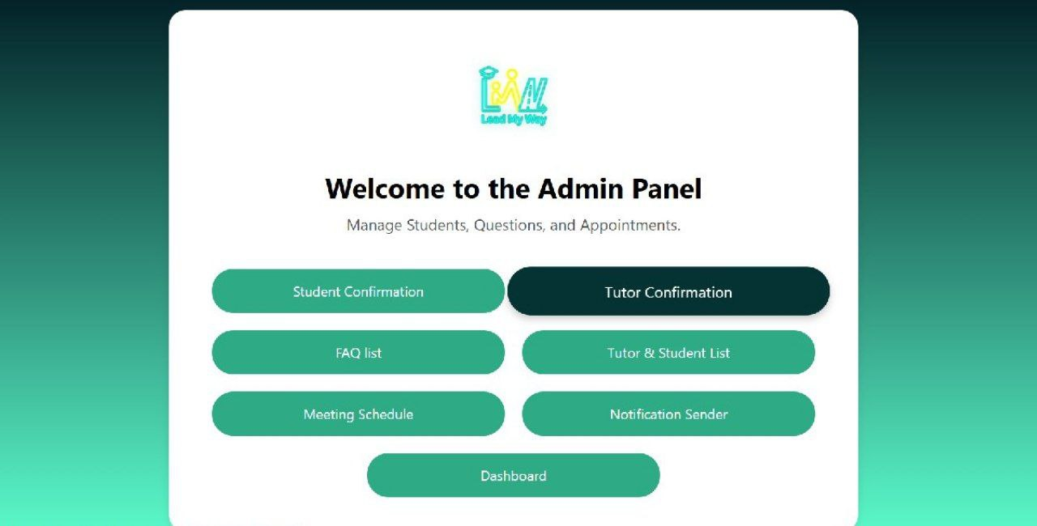

Figure 7. Admin’s Panel

### Ⅰ.V.2.4 Technologies and Tools Used:

Table: Technologies and Tools Used

|  |  |
| --- | --- |
| Frontend | HTML5, CSS3, JavaScript |
| Backend | PHP |
| Database | MySQL |
| Asynchronous Requests | JavaScript fetch API |
| Architecture | Draw.io |
| Version Control | Git & GitHub (for code management and collaboration) |
| UI/UX Design | Figma (for interface prototyping and consistency) |
| Development Tools | VS Code, phpMyAdmin, XAMPP |
| Project Management | Git&GitHub Issues local task planning |



# **General Conclusion**

# **V. 1. Conclusion:**

Each academic year, the Ministry of Higher Education takes several measures to ensure a smooth start to the university year. Among these measures is the social and academic support provided to new baccalaureate holders. This support is ensured by a unit composed of doctors, psychologists, teachers, and former students.

At the departmental level, this support task is known as tutoring. It is carried out by tutors, who may be either teachers or former students holding at least a Master’s degree. These tutors follow and assist new students throughout the entire academic year, answering all their questions.

It is within this context that the present project was developed. It aims at managing all functions related to the tutoring task through the implementation of a hybrid tutoring system (both in-person and online). This system, called Lead My Way, allows new students in the Computer Science department to contact their tutors at any time and from anywhere to request assistance. Additionally, tutors have access to a dashboard through which they can schedule appointments with students, respond to their inquiries, and more.

The developed system includes three interfaces dedicated to the system's human users: the administrator, the tutor, and the student. Each interface offers a set of features that simplify the tasks assigned to its user.

Finally, we can confirm that the initial objectives of the project have been successfully achieved. The system provides a set of functionalities that address the common issues faced by students during their first university year. Real-life use by students may reveal certain anomalies and lead to further improvements in the future

# **V. 2. Difficulties Encountered**

Obstacles are a natural part of the learning and development process. In our case, several difficulties emerged testing our skills, team work, and flexibility.

**First,** the project turned out to be far more ambitious than our skill level allowed. Most of us had little to no experience with real web development, and diving into PHP and MySQL while simultaneously building the backend proved to be overwhelming.

**Second,** we faced significant difficulties organizing our code and integrating the various components of the project. Working as a team, we had to coordinate contributions from multiple members, ensuring a unified tone was particularly challenging.

**In addition,** debugging became frustrating as we struggled to identify and resolve issues without a solid foundation in debugging techniques.

**Finally,** managing our time and focusing between studying the required modules and developing the project was a major problem. Understanding the theoretical concepts from our coursework was essential to make informed decisions during development, but the project also demanded immediate practical application, critical problem-solving and close collaboration. This balancing act created stress and left little room for deeper research or refining our skills.

Despite the obstacles, the experience taught us valuable lessons in teamwork, time management, and the importance of planning within our capabilities.

# **V. 3 Limitations and Anomalies in the system**

# **V.3.1 Limitations:**

1-The system does not yet support the forgotten password feature.

2-There is no real-time notification system to inform users of new events.

3- Unlike tutors and students, admins doesn’t have a profile interface.

4-The dashboard displays figures, but without graphs or dynamic filters.

5- The system does not support multiple languages (currently only English).

6- The system is not yet responsive or optimized for mobile phones.

# **V.3.2 Anomalies:**

A few anomalies in the system were also observed during the testing phase.

1. Using fetch() queries with PHP was new to us.

2. Session and security management required a lot of research.

3. Sometimes, simple errors took a long time to detect (typos, field names, ...etc).

# **V. 4 Futur Perspectives**

The ‘LEAD MY WAY’ system has the potential to evolve into a comprehensive academic support platform for first-year university students. In the future, several improvements and additions could amplify the system’s efficiency. With regular updates, “LEAD MY WAY” could become a smart, adaptive platform that grows with the needs of each academic generation.

As the system evolves, the current anomalies will be resolved through improved planning, better tools, and gained experience. Our planned future enhancement includes:

-**Mobile Access:** This approach focuses on making the existing website fully accessible on mobile devices. By optimizing the website for smartphones and tablets, students can easily log in and navigate the platform from their mobile browsers at any time.

-**Real-Time Messaging System (chat):** A built-in chat system will enable instant communication between students and tutors, making interactions faster and more efficient.

-**Automatic Tutor Reports Activity:** The system will generate regular activity reports for tutors, helping track their performance and engagement. -**Password Recovery:** The system will allow tutors and students to easily retrieve their accounts if they forget their login credentials.